Exercise: App Monitoring
Exercises for the "Containers and Clouds" course @ SoftUni

Monitor the "Contact Book" Node.js App with Prometheus
We have the Node.js "Contact Book" app in the resources. We aim to monitor it using Prometheus, so we need its metrics. In this case, we will instrument the app to expose the metrics we want. And then we will configure Prometheus to display these metrics.
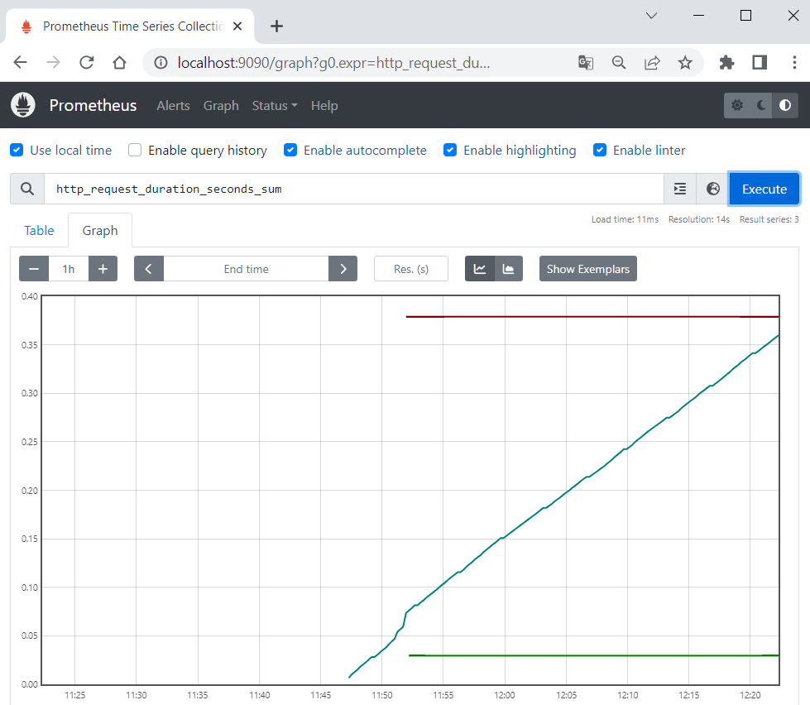

Step 1: Examine the App
We have the "Contact Book" Node.js app, which holds a searchable list of contacts. You have pages to list all contacts (/contacts), view a single contact (/contacts/:id), search for a contact (/contacts/search/:keyword) and add a new contact (/contacts/create).
Open the project in Visual Studio Code to examine its files:
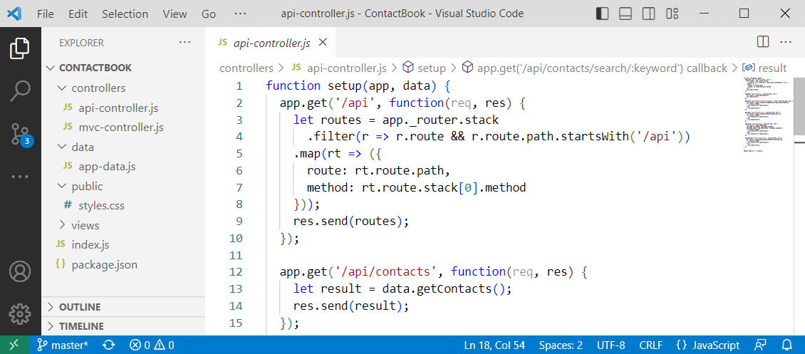
Open a terminal and execute the "npm install" and "npm start" commands to run the app:
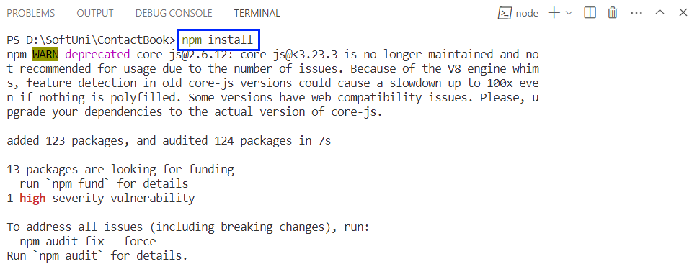
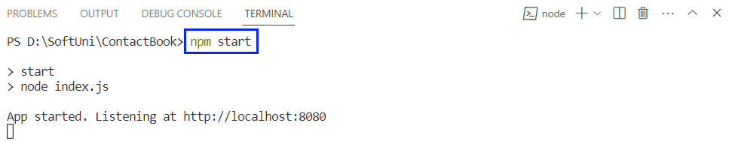
Look at the app pages on http://localhost:8080:
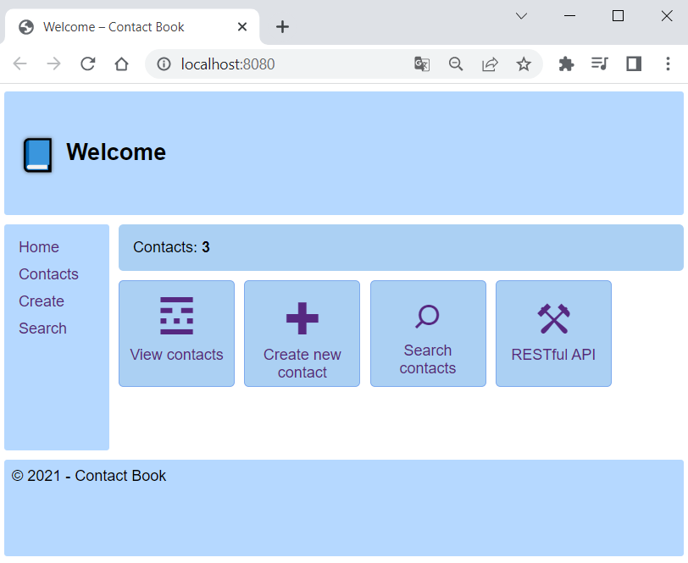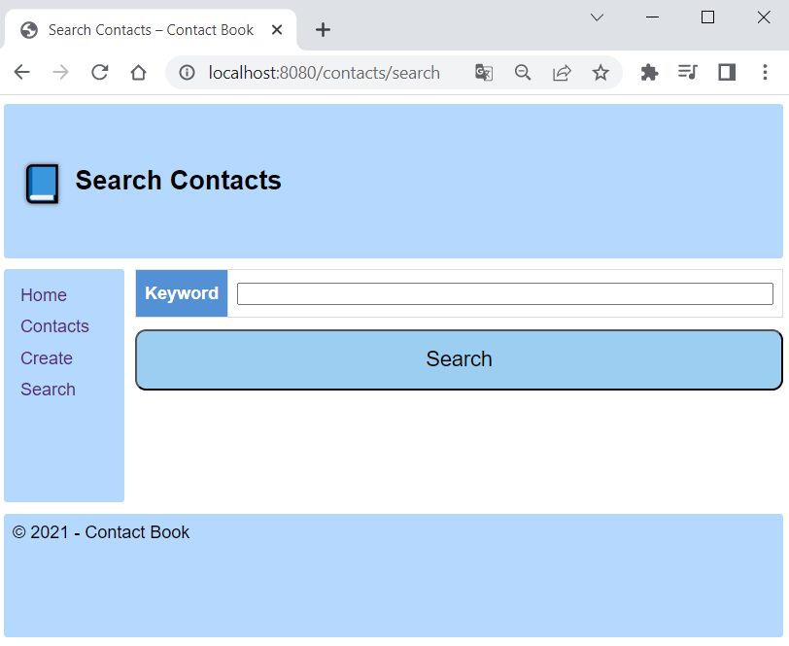
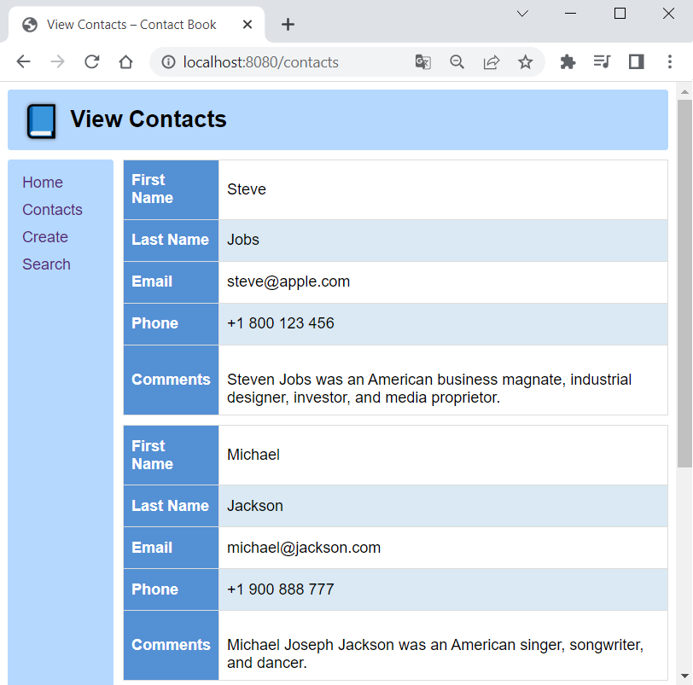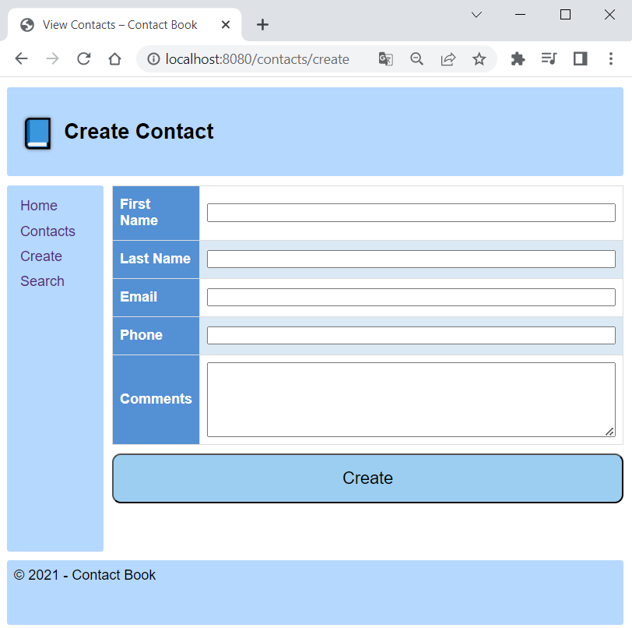
Let's now see how to modify the app code to export app metrics for Prometheus.

Step 2: Export Node.js App Metrics
To make app metrics readable for Prometheus, we should install an additional client library for Node.js and then modify the code to define and export the metrics we want.

Install Prom-Client
Stop the app with [Ctrl] + [C] in the terminal. Then, we should install the prom-client package, which is the Prometheus client for Node.js that supports histogram, summaries, gauges and counters. Do it with the following command:
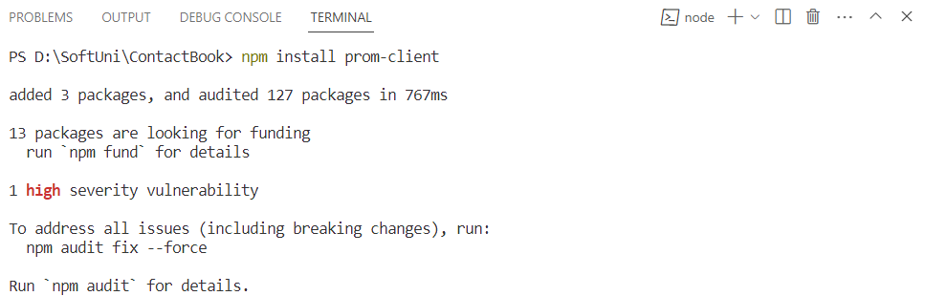
You can see that the prom-client package is added to the package.json file with project dependencies:
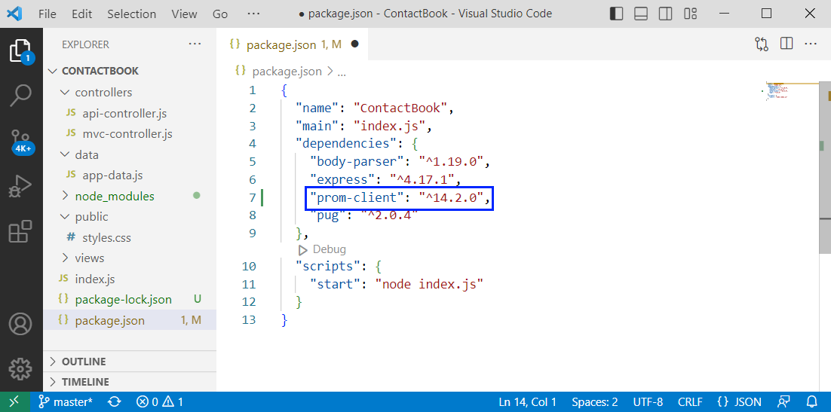
Because of this, you won't need to install the package separately from the others next time.

Export Default Metrics
Now we will modify our code to collect the default app metrics together with some custom ones and expose them on the /metrics endpoint.
To do this, navigate to mvc-controller.js file where the main app routing is and include the prom-client module, as we will need it:
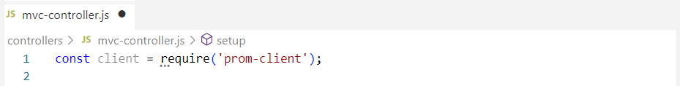
Then, create a registry to register the metrics:
Use the collectDefaultMetrics() function from the imported module to collect and register default metrics for monitoring the Node.js application, for example CPU usage, memory usage, event loop latency, and garbage collection duration:
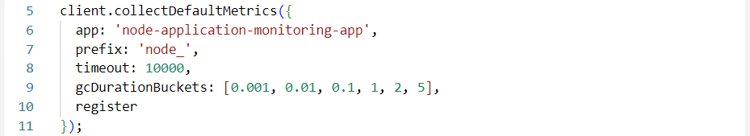
This configuration sets default metric names to start with the "_node" prefix, the timeout to 10000ms, the buckets for the default metric that measures garbage collection (GC) durations (values represent the upper bounds of each bucket) and the registry that we created to be used.
These are the default metrics we will export. Now, in the setup() function, set up an HTTP GET route for the /metrics endpoint, which should return the collected app metrics as response:
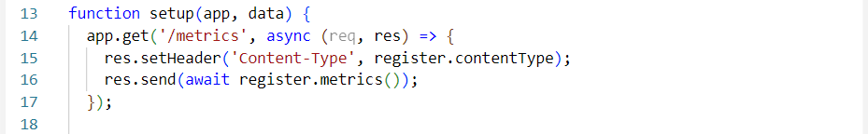
Before we add some custom metrics, let's see how default metrics are showed. Save the changes and start the app again. Then, navigate to http://localhost:8080/metrics in the browser:
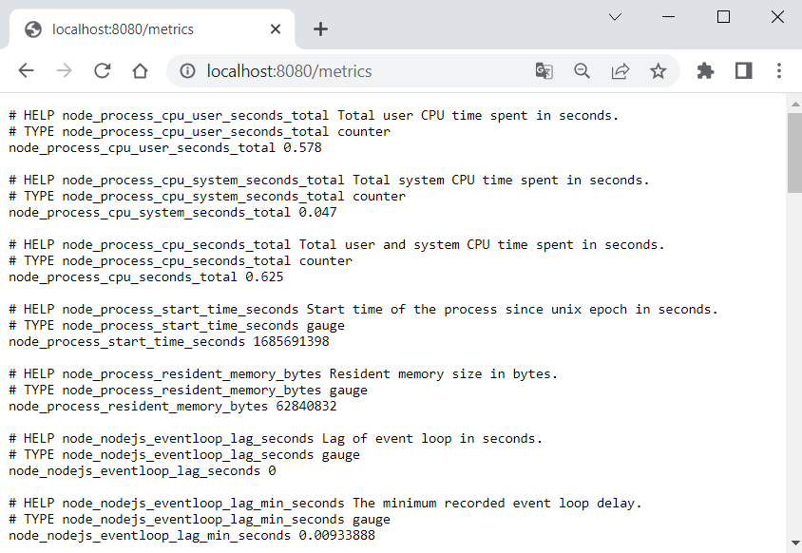
Now let's add some more metrics.

Export Custom Metrics
The custom metrics we shall export are about the duration of HTTP requests to different endpoints in seconds. They will be saved in a histogram with buckets from 0.01 to 1 seconds and will keep request method, route and status code.
Add the following code to create the histogram metric (before the setup() function):
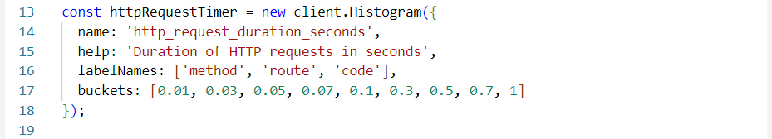
Then we should register the metric:
Now, for each of the routes, we should:
- Start an HTTP request timer, saving a reference to the returned method
- Save reference to the path so we can record it when ending the timer
- And finally end the timer and add labels
In this way, the HTTP request data and duration will be recorded. Do it for the /metrics endpoint like this:
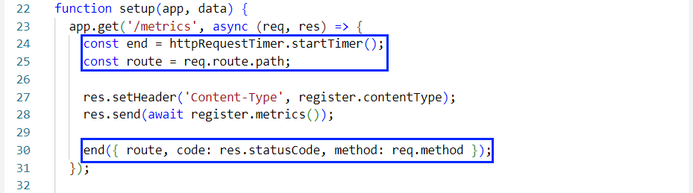
Do it for the rest of the endpoint methods in the same way by adding the above three lines. When ready, run the app again.
When you first access /metrics, you will see the new metrics at the bottom:
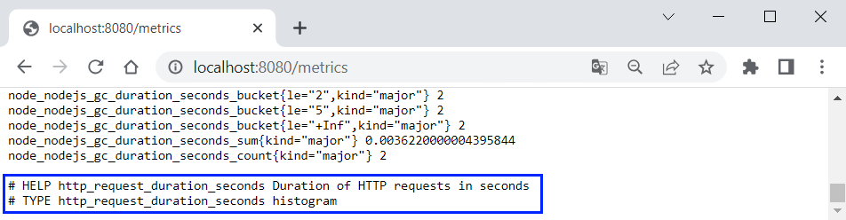
However, you still have no metric values. You should refresh the page, so that the metrics for the previous HTTP request to /metrics are displayed:
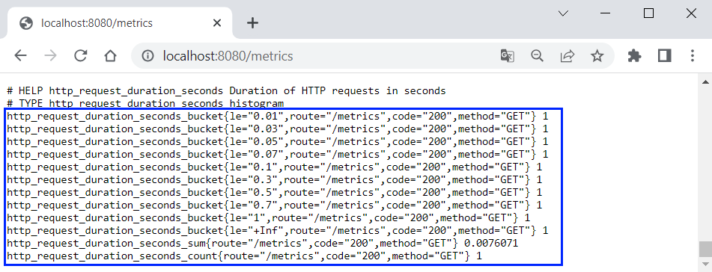
As you can see, the first HTTP request to /metrics took about 0.0076 seconds, which is less than 0.01 and that's why it falls into each of the buckets.
If you access the other app endpoints, you will get even more metric data:
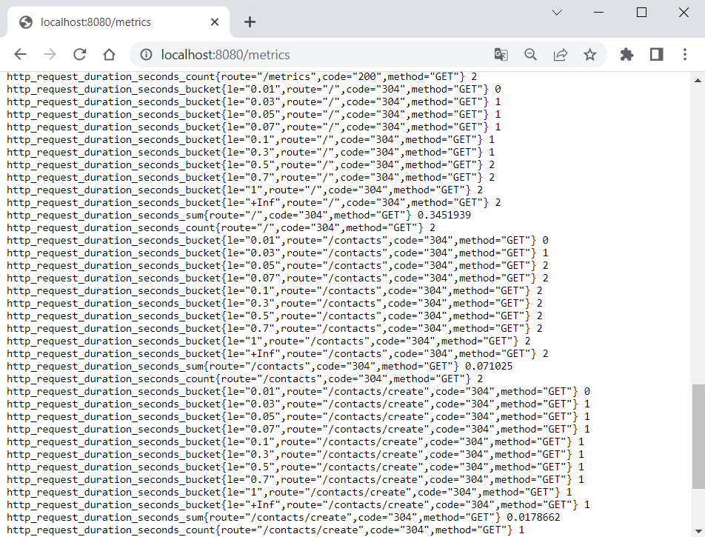
You can use the browser inspector in the browser to compare the HTTP request times shown here and there – they should be pretty close as values.

Step 3: Condifure and Run Prometheus
Go to the Prometheus installation directory where our binary files are and create a YAML file where we will write the configuration for monitoring the "Contact Book" app:
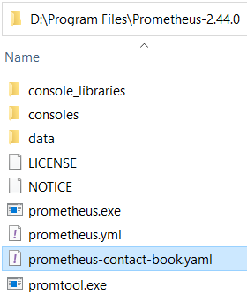
In the Prometheus configuration file, we should define а single job to monitor our app on http://localhost:8080 and scrape target metrics on every 15 seconds:
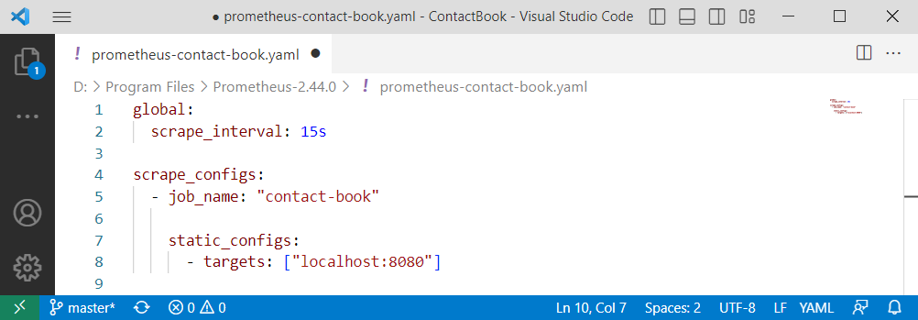
Save the file and open a terminal. Navigate to the Prometheus installation directory and run Prometheus with this configuration file:
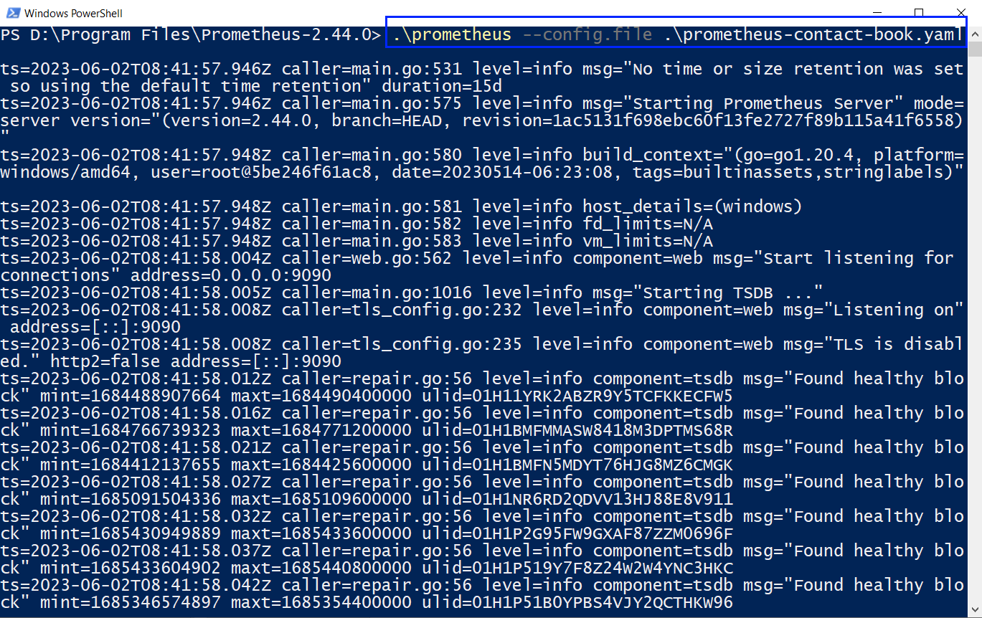
Prometheus server should be available on http://localhost:9090 by default:
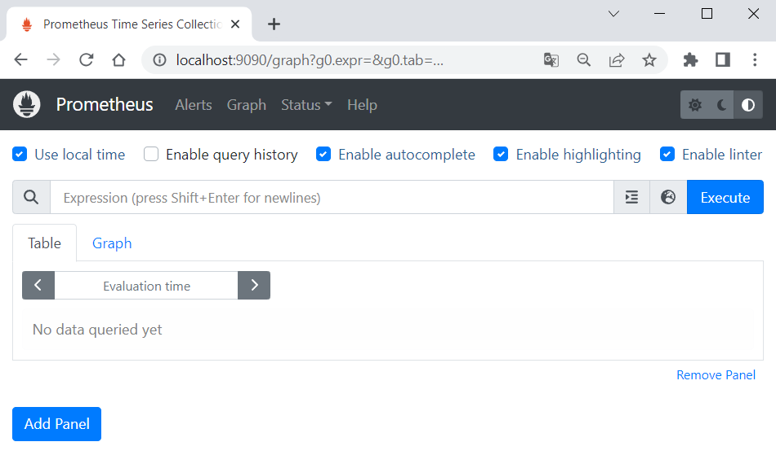
You can navigate to [Status] [Targets] to see that Prometheus connects to the configured target app successfully:
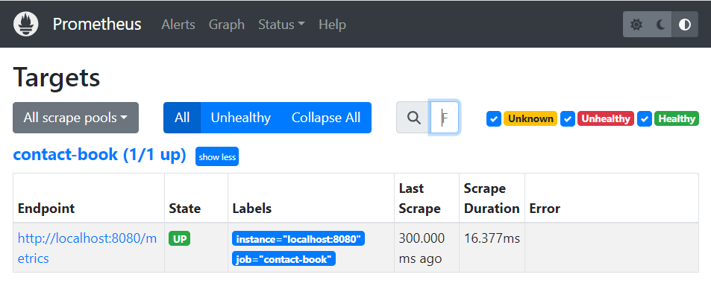
NOTE: the "Contact Book" app should be running to expose metrics.
Now you can go back to the [Graph] page and display some of the metric values, using an expression. For example, let's see the count of all different HTTP requests:
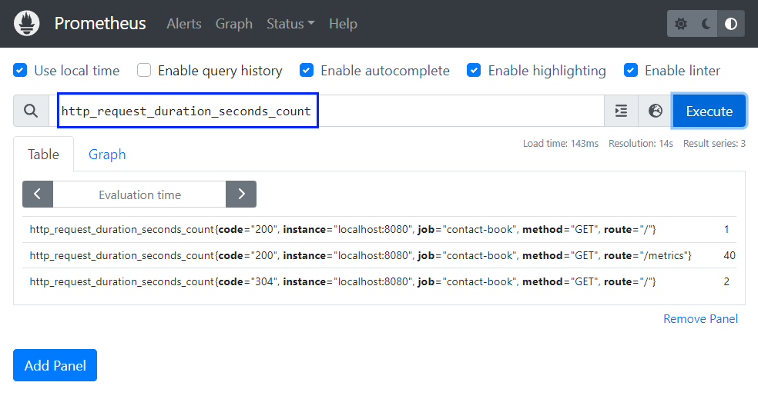
Switch to [Graph] to look at a graph for the metric:
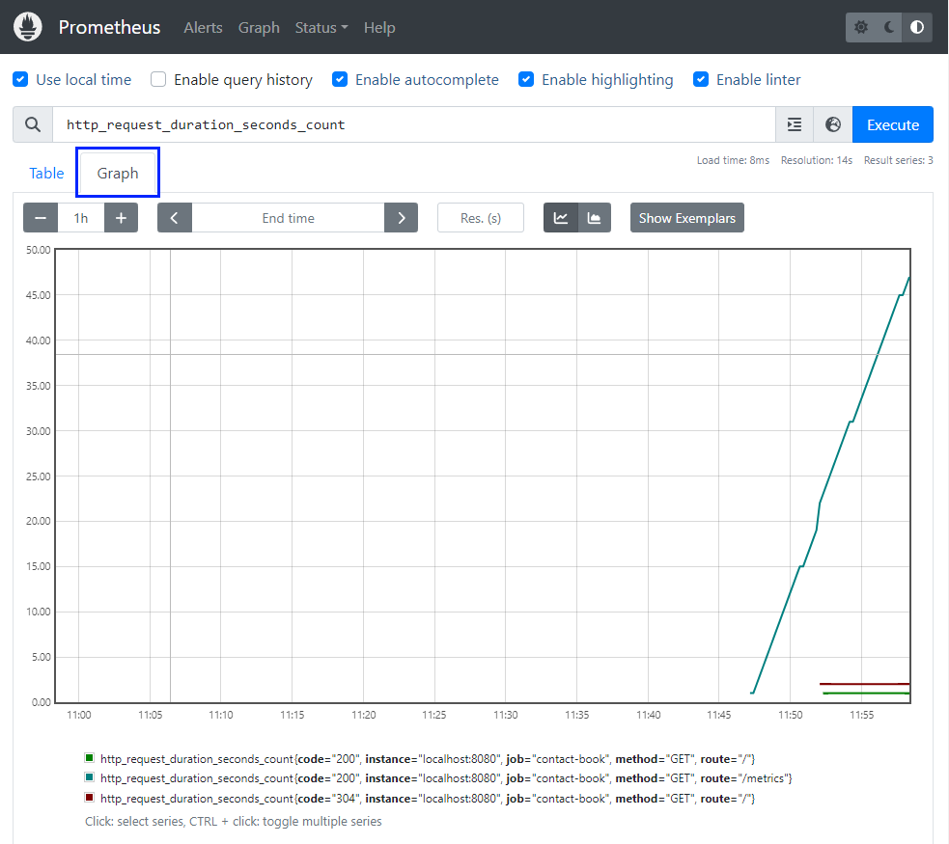
You can examine more metrics you want. When metrics change, click on [Execute] to load the changed graph.
As we know how to work with Prometheus, let's see how to add Alertmanager to manage alerts and send notifications.

Manage "Contact Book" App Alerts with Alertmanager
In this task, we will manage Prometheus alerts with Alertmanager and send them to Webhook.site to keep them. Our aim is to fire alerts when any page has been accessed more than 3 times during a 5-minute period.

Step 1: Configure and Run Alertmanager
Let's first see how to write a configuration file for Alertmanager to handle alerts. First, create a YAML file in the Alertmanager installation directory:
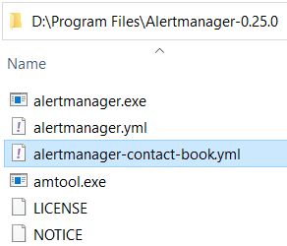
Open the file in an editor and write the sample configuration below:
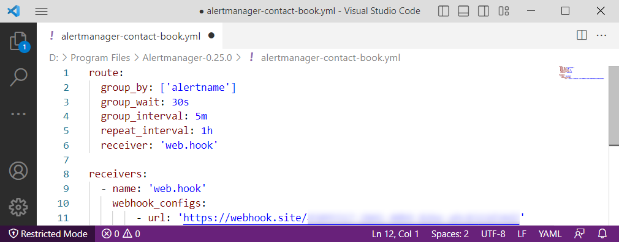
This configuration:
- Groups alerts by their name
- Sets alerts to be grouped together for a period of 30 seconds before being sent
- Sets notifications for unresolved alert groups to be sent every 5 minutes
- Sets notifications for unresolved alerts to be repeated every 1 hour
- Defines notification receiver to be "web.hook"
- Configures receiver
As you can see, the configuration contains a Webhook.site URL, which is unique. Webhook.site allows us to create temporary endpoints (webhooks) and capture the incoming requests sent to those endpoints, e.g., our Prometheus notifications.
To get your URL, navigate to Webhook.site and copy the provided URL, without closing the browser tab after this:
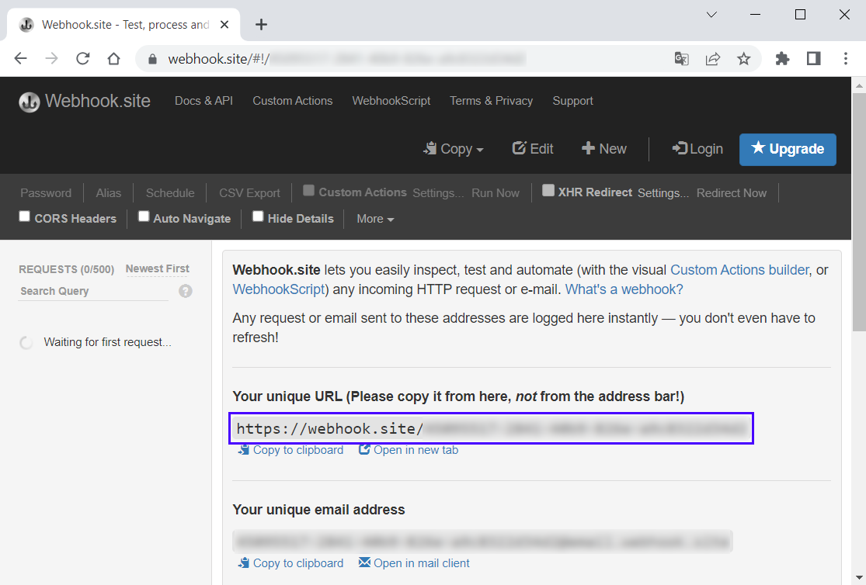
Add the URL to your configuration file and save it.
Next, run Alertmanager with the configuration file:
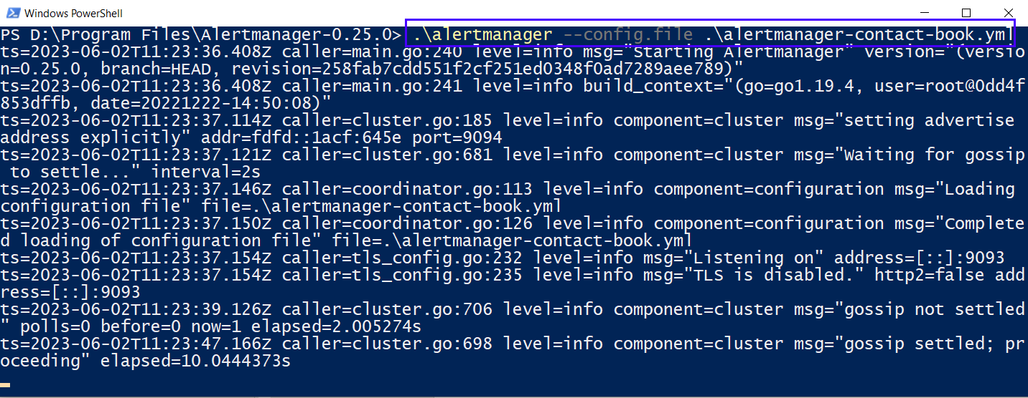
Go to http://localhost:9093 in the browser and you should see that Alertmanager is up and working:
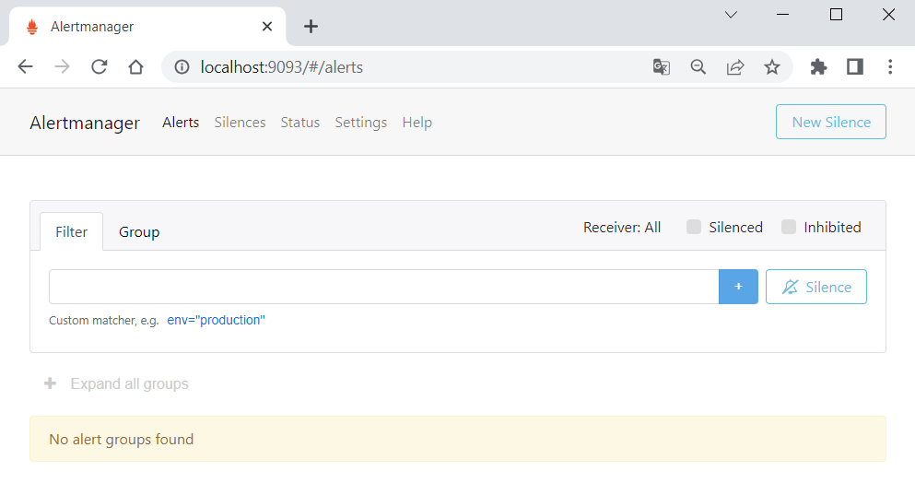
Now let's configure Prometheus to work with Alertmanager.

Step 2: Configure and Run Prometheus
We should do 2 things to make Prometheus send alerts to Alertmanager – first, create a YAML file with rules for firing an alert and, second, modify the Prometheus configuration file to use the rules and send alerts to Alertmanager.
Create a new YAML file in the Prometheus installation directory, which will define alert rules:
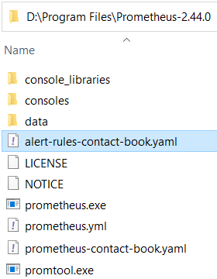
As we said earlier, we will fire an alert when an endpoint is accessed more than 3 times for 5 minutes. We will measure that using the http_request_duration_seconds_count metric – if its value has changed more than 3 times for the last 5 minutes. We shall have the following expression:
changes(http_request_duration_seconds_count[5m]) >= 3
Note that in our case we count how many times the requests count has changed on data scrape (on every 15 seconds), not how many times the count has changed generally.
Having this expression, add the following rules configuration to the created YAML file:
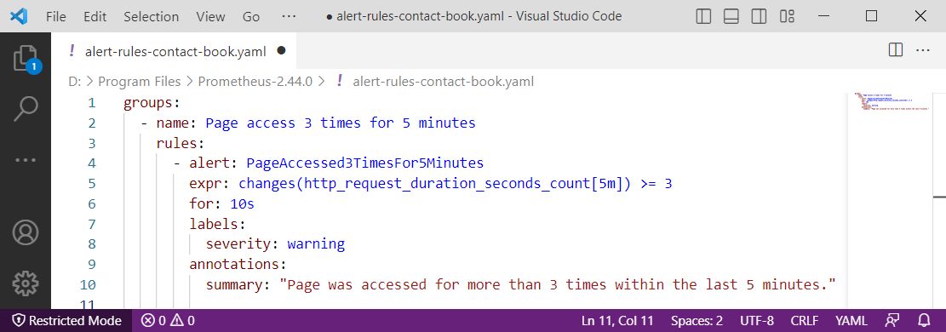
Here we have a single rules group and an alert that will be fired if the given expression is true for at least 10 seconds. The alert will have a label and summary.
Save the file and let's modify (or create a new separate file) the Prometheus configuration. It should look like this:
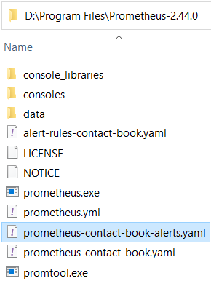
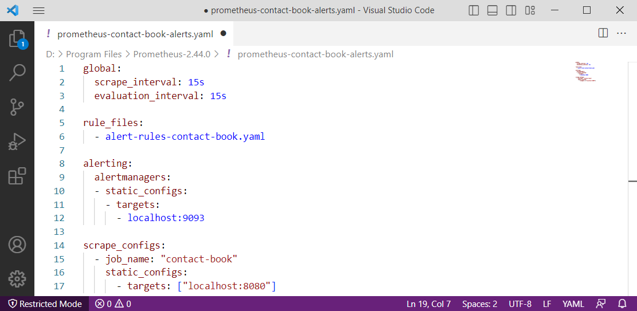
As you can see, we have added the name of the rules file and configurations for connection to Alertmanager, which is accessible on http://localhost:9093 by default. Also, we have set evaluation_interval, which is the interval based on which Prometheus evaluates the query for alerting.
Now you should run Prometheus with the new / modified configuration file (don't forget to change the name of the configuration file if you have named it in a different way):
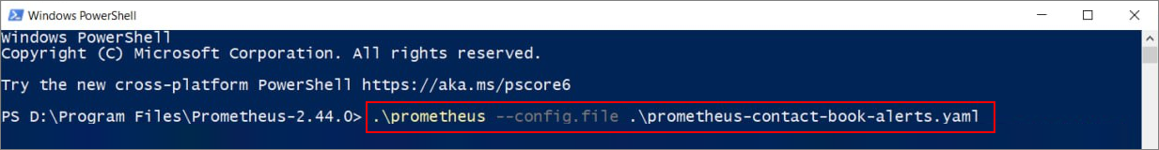Go to the Contact Book app on http://localhost:8080/ and reload the page more than 3 times. Now, access Alertmanager on http://localhost:9093 and you should be able to see the new alert:
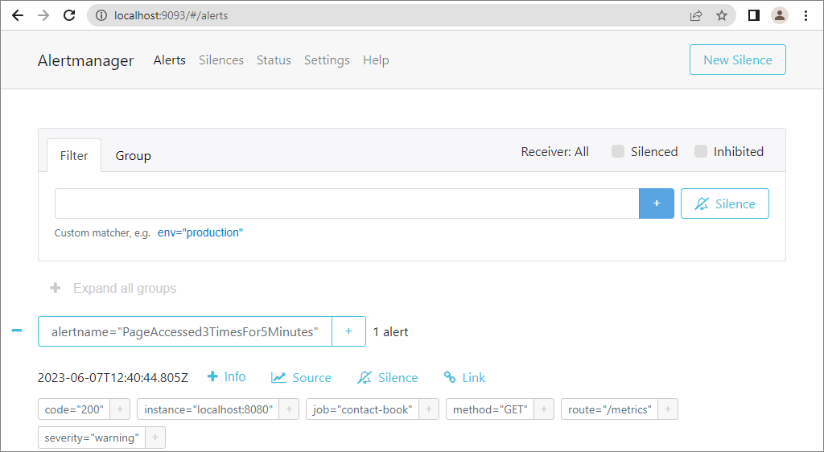
Now, visit the opened tab with Webhook.site. You should be able to see the detailed info about the sent incoming requests:
